Jordan Isaac
CS 330 Milestone One
5/17/2026
Project Proposal for Milestone 1:
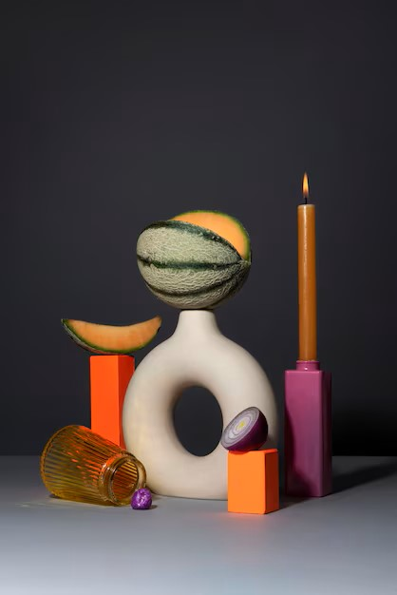
This is the scene that I will be using for the Milestone 1 part of this project. From the scene, the selected items for 3D replication are the vase, candle, glass, geometric blocks, and a plane. These items are ideal choices because they showcase a diverse range of basic shapes, such as the torus for the vase, the cylinder for the candle, the tapered cylinder for the glass, and the box for the geometric blocks. This combination creates a balanced and engaging scene that combines simplicity with visual interest. Additionally, the inclusion of the plane helps ground the entire composition, ensuring all elements feel connected.
Breaking down the objects further, the vase will use a torus shape to represent its hollow, circular design. The candle will rely on a cylindrical shape for its main body, complemented by a small cone if a flame is included. The glass, with its narrowing structure, will be best captured as a tapered cylinder. The geometric blocks will take the form of straightforward rectangular prisms boxes for simplicity and versatility. Finally, the plane will serve as the foundational surface to anchor all the elements in the scene.
This selection of objects and shapes ensures a scene that is both compelling to create and manageable to execute. The variety of shapes keeps the layout visually exciting, while their simplicity maintains feasibility. By starting with the plane as the base, each object can be modeled, positioned, and textured in a cohesive and harmonious manner, reflecting the richness of the original still life image.

